Problem Set B Submission Form

# Overview

|  |  |
| --- | --- |
| Your Name | Jaya Varshini Prabakar |
| Your SU Email | jprabaka@syr.edu |

# Instructions

Put your name and SU email at the top. Answer these questions all from the lab. When asked to include screenshots, please follow the screen shot guidelines from the first homework.

Remember as you complete the homework it is not only about getting it right / correct. We will discuss the answers in class so it’s important to articulate anything you would like to contribute to the discussion in your answer:

* If you feel the question is vague, include any assumptions you've made.
* If you feel the answer requires interpretation or justification provide it.
* If you do not know the answer to the question, articulate what you tried and how you are stuck.
* Highlight any doubts or questions you would like me to review.

This how you receive credit for answering questions which might not be correct. In addition, you must complete the reflection portion of the homework assignment for full credit. Since most answers will be similar this is an important part of your individual submission.

Complete Part II of this document first, then go back and complete the Reflection in Part I.

# Part I - Reflection

Use this section to reflect on your learning. To achieve the highest grade on the assignment you must be as descriptive and personal as possible with your reflection.

1. As you completed this assignment, identify what you learned.  
   Docker fundamentals, what is Docker image, container, volume and commands to execute and get information
2. What barriers or challenges did you encounter while completing this assignment?  
   I didn’t face any barriers or challenges
3. How prepared were you to complete this assignment? What can you do to be better prepared?  
   I am well prepared to complete the assignment
4. Rate your comfort level with this week’s material. Use the rubric provided.

**4 -** I understand this material and can explain it to others.  
4 ==> I understand this material and can explain it to others.  
3 ==> I understand this material.  
2 ==> I somewhat understand the material but sometimes need guidance from others.  
1 ==> I understand very little of this material and need extra help.

# Part II – Questions

Paste your answers to the Exercises found in the lab document. Make sure to include your netid in any screenshots you provide. If the question asks for commands, only include those commands which are necessary to complete the tasks. Number each answer.

1. Take a screenshot of an open Windows Terminal with the current working directory set to the **advanced-databases** folder. Make sure to follow the screenshot guidelines and include your name/netid in the screenshot.

1. Explain the difference between a Docker image and a container. No screen shot necessary.  
   **Docker Image:** A docker image is like a blueprint of software applications contents. It is a bundle of application dependencies.

**Docker Container:** A container is a running instance of an Image, it is created from docker images. Each container runs on its own isolated environment making it secured from other containers.

1. What is the purpose of a docker volume? No Screen shot necessary.  
   The purpose of a Docker Volume is to provide a continuous updated storage that updates the container file within a host system. By creating a volume directory in host system ensures that any changes made in container is available even after that container if stopped/removed.
2. Start the redis and retwis services with docker-compose. Provide a screenshot of the command you typed, and another screenshot showing the two services are running.  
   

1. What does the last line in the redis logs say? Provide a screenshot of this message. What command did you have to type to see the redis logs?  
   Command types: docker logs advanced-databases-rediscommander-1

The last line of redis log is Redis Connection redis: 6379 using Redis DB #0

1. Which ports are being used by the currently running docker services? How do know they are running, and which ports are being used?

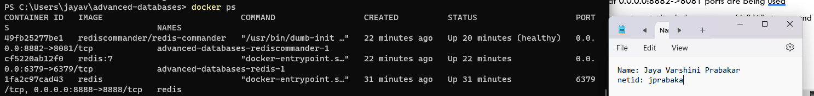

From the above image we can see that 0.0.0.0:8882->8081 ports are being used. And a docker ps command will tell if they are running and what ports are used.

1. What are the volumes created by all the services in the docker-compose file? What command did you type to get this answer and provide a screenshot of the output.

I used docker volume ls to see all the volumes created by all services in the docker compose file.

